CS2023 - Inclass Lab

Week 10 - Graphs

**Note: You are required to answer the below questions and submit a PDF to the submission link provided under this week before the deadline (no extensions will be provided). You can either write / type your answers, but either way your answers should be readable.**

**Add the link to the GitHub repository**

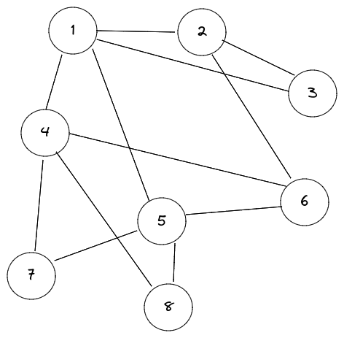

Figure 1: Graph for Section 1

# Lab instruction

Please download the lab materials from the lab 10 section We will be implementing a Graph Abstract Data Type (ADT) in section 1 and section 2 we will be working a problem of link prediction. Section 1 requires coding, Section 2 DO NOT require coding.

Section 1 : Implementing Graph ADT

Expected submission

1. Write the adajaceny list representation for the graph in Fig1
2. By using comments provided in the code, complete the following *Node (struct), intializenodes, addedge, print functions*
3. Create graph object and add the graph in Fig.1.
4. Print the adjacency list using the *print* function you implemented and take screenshot.
5. What is the change you will make in the *addedge* function so that Graph ADT could accept directed graphs.(Instead of accepting undirected graph, we need to accept directed graph). Write addedge altered function as your answer below.

Section 2 : Working out link prediction, no coding required

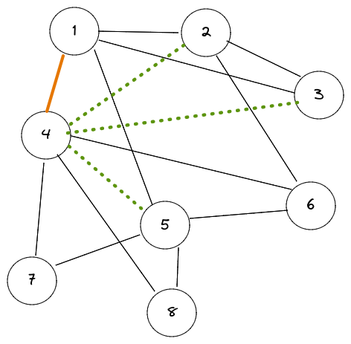

Figure 2: Graph for Section 2

To predict whether two nodes may have edge between them in the future, we must define a similarity score between the 2 nodes. Use the following similarity equation to calculate the similarity between 2 nodes,

# of shared neighbours between a,b *a* ∩ *b*

*Sim*(*a,b*) = =

Total neighbours in a,b *a* ∪ *b*

Refer graph in Fig.2 to answer the question below.

Lets assume graph in Fig.2 is a social network graph of a social media platform, where nodes denote people and edges between them indicate that they are connected as friends. Node 1 and Node 4 just became friends, which of the neighbours of Node 1 will you suggest for Node 4 (in other word predict which neighbour of Node 1 can have a edge with Node 4). Utilize the similarity function provided to justify the answer.

**Answers**

Section 1:



1: [2,3,4,5]

2: [1,3,6]

3: [1,2]

4: [1,6,7,8]

5: [1,6,7,8]

6: [2,4,5]

7: [4,5]

8: [4,5]

2)

3)

4)

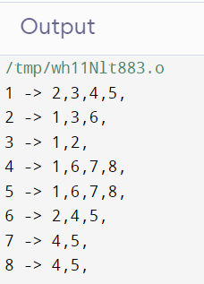

5)



Section 2:

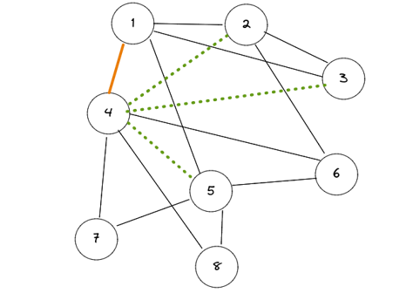

* Neighbors of 1 -> 2,3,5,(4)
* Let’s calculate similarities between 4 and neighbors of 1.

Sim(4,2) = $\frac{2}{5}$

Sim(4,3) = $\frac{1}{5}$

Sim(4,5) = $\frac{4}{4}$

* The highest similarity is between 4 and 5. Hence 5 is the best suggestion.